Perception of the counsellor...............
🧠 Perception of the Counsellor (Biblical + Practical View)

📌 What is “Perception of the Counsellor”?
👉 Perception of the counsellor means:
How the counselor sees, understands, and interprets the person, problem, and situation.
It is not just listening to words —
👉 It is seeing the heart, emotions, and spiritual condition.

✝️ Biblical Foundation
📖 1 Samuel 16:7
👉 “Man looks at the outward appearance, but the Lord looks at the heart.”
💡 Teaching:
- People see behavior
- God sees the heart
- A counselor must learn to see like God

🔍 1. Right Perception: Seeing Beyond Words
People say one thing… but feel another.
Example:
- “I am fine” → actually hurt
- “I am angry” → actually feeling rejected
👉 Good counselor asks:
“What is happening in the heart?”

❤️ 2. Heart-Focused Perception
📖 Matthew 15:18
👉 Words come from the heart
Counselor should identify:
- Pain
- Fear
- Pride
- Insecurity
- Unforgiveness
💡 Key Principle:
👉 Behavior is the fruit; heart is the root

🪞 3. Self-Awareness of the Counsellor
A counselor must check their own perception:
Ask:
- Am I judging? ❌
- Am I assuming? ❌
- Am I listening with love? ✅
📖 Galatians 6:1
👉 Restore gently

👂 4. Listening with Spiritual Discernment
Not just hearing words, but:
- Tone
- Emotions
- Silence
📖 Proverbs 20:5
👉 The heart is deep waters — draw it out

⚠️ 5. Wrong Perception (Common Mistakes)
❌ Judging quickly
❌ Taking sides
❌ Ignoring emotions
❌ Focusing only on behavior
❌ Giving advice too fast
👉 This leads to wrong counseling

🌿 6. Christ-Centered Perception
👉 A biblical counselor sees through:
- ✝️ Christ’s compassion
- ❤️ Love
- 🕊️ Holy Spirit guidance
📖 Colossians 3:12
👉 Compassion, kindness, humility

🔄 7. Counseling Model Connection
👉 Christ → Heart → Behavior → Relationship
Perception role:
- Identify heart problem
- Not just behavior

🎭 Mini Role Example
Person: “My husband is always angry!”
❌ Wrong perception:
👉 “Your husband is the problem”
✅ Right perception:
👉 “What is happening in his heart?
What is happening in your heart?”

💡 Powerful Teaching Line
👉 “A good counsellor does not just hear words — they understand the heart behind the words.”

📌 Bilingual Summary
English:
Perception in counseling means seeing the heart behind behavior with love, wisdom, and spiritual understanding.
Tamil:
ஆலோசனையில் பார்வை என்பது வெளிப்புற நடத்தைக்கு பின்னால் இருக்கும் இதயத்தை அன்போடும் ஞானத்தோடும் காண்பது.

🏁 Final Insight for Trainers
👉 Transformation begins when:
- Perception changes
- Heart is understood
- Christ is introduced

If you want next, I can create:
✅ 🎨 Visual infographic (like your previous images)
✅ 📊 PPT slides (training ready)
✅ 🎭 Role play based on perception errors
✅ 📘 Advanced counseling module
Just tell me 👍
Today's world what's happening?...... for counselling how can i teach?
Here’s a teaching-ready guide you can use for pastors, leaders, and counselors on:
🌍 “Today’s World – What’s Happening & How to Teach Counseling”

🌍 1. What’s Happening in Today’s World?



5
🔍 Key Realities:
😔 1. Emotional Brokenness
- Anxiety, depression, loneliness increasing
- People feel empty despite success

💔 2. Family Breakdown
- Conflicts in marriage
- Lack of communication
- Increase in separation

📱 3. Digital Disconnection
- More screen time, less heart connection
- Families live together but are emotionally distant

😡 4. Anger & Stress
- Pressure from work, finances, expectations
- Leads to frustration and conflict

❌ 5. Loss of Values
- Truth replaced by opinions
- Self-centered living

✝️ 2. Root Problem (Biblical View)
👉 The real issue is not outside… it is inside
📖 Jeremiah 17:9
“The heart is deceitful…”
👉 Problem = Heart problem (sin, brokenness, disconnection from God)

🧠 3. Counseling Teaching Model
🌿 Core Model:
👉 Christ → Heart → Behavior → Relationship

🪜 4. How to Teach This (Step-by-Step)
🎯 Step 1: Start with Reality
Ask:
- “What problems do you see in families today?”
- “Why are people not happy?”
👉 Let them speak

🎯 Step 2: Identify the Root
Explain:
- Problem is not just situation
- It is the heart condition
💡 Example:
- Anger → hurt heart
- Silence → fear or rejection

🎯 Step 3: Introduce Christ
📖 John 14:6
👉 Jesus is the solution
Teach:
- Only Christ changes the heart

🎯 Step 4: Explain Heart Transformation

4
👉 When heart changes:
- Behavior changes
- Relationships heal

🎯 Step 5: Apply to Family
Example Teaching:
- Husband anger → heart issue
- Wife hurt → emotional need
👉 Solution:
- Christ-centered love
- Forgiveness
- Communication

🎭 5. Teaching Illustration (Simple Story)
👉 “A tree gives bad fruit…”
Ask:
- Do we fix fruit OR root?
👉 Answer:
- Root
💡 Teaching:
👉 Heart = Root
Behavior = Fruit

🛠️ 6. Practical Teaching Tools
Use:
- Role plays 🎭
- Real-life examples
- Questions & discussion
- Bible verses
- Visual charts

⚠️ 7. Important Warning for Counselors
Do NOT:
- Only give advice ❌
- Judge quickly ❌
- Focus only on behavior ❌
Do:
- Listen deeply ✅
- Understand heart ✅
- Bring Christ in ✅

💡 Powerful Teaching Line
👉 “Today’s world is full of problems because hearts are empty — only Christ can fill and transform the heart.”

📌 Bilingual Closing
English:
Today’s problems are not just social—they are spiritual. True counseling begins with heart transformation through Christ.
Tamil:
இன்றைய உலகின் பிரச்சனைகள் வெளிப்புறமானவை அல்ல; அது ஆன்மீகமானவை. உண்மையான ஆலோசனை கிறிஸ்துவால் இதயம் மாற்றப்படுவதில் தொடங்குகிறது.

Perception of the Counsellor (Biblical + Practical View)
Here is a complete teaching module you can use for pastors, counselors, and training sessions:

🧠✝️ Perception of the Counsellor
(Biblical + Practical View)

📌 1. What is “Perception” in Counselling?
👉 Perception means how a counsellor:
- Sees 👀
- Understands 🧠
- Interprets ❤️
the person, problem, and situation.
💡 It is not just hearing words…
👉 It is discerning the heart behind the words

✝️ 2. Biblical Foundation of Perception
📖 1 Samuel 16:7
👉 “Man looks at outward appearance, but the Lord looks at the heart.”
Teaching Insight:
- Humans focus on behavior
- God focuses on the heart
- A biblical counsellor must learn to see like God

❤️ 3. Heart-Focused Perception
📖 Matthew 15:18
👉 Words come from the heart


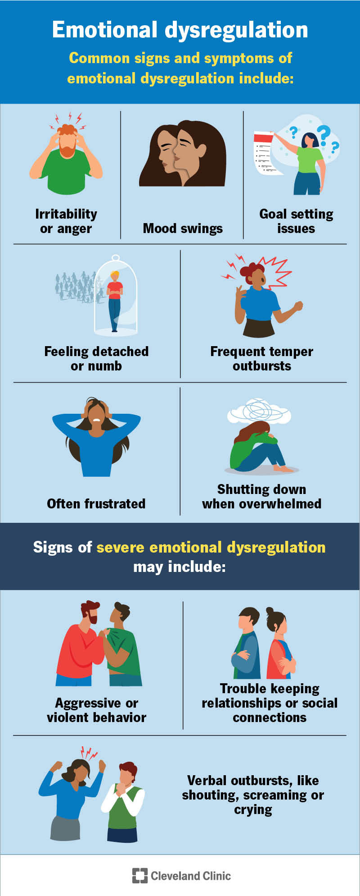
4
Key Principle:
👉 Behavior = Fruit
Heart = Root
Example:
Behavior | Heart Issue
Anger | Hurt / insecurity
Silence | Fear / rejection
Control | Anxiety / lack of trust

👂 4. Deep Listening (Practical Skill)
A counsellor must listen at 3 levels:
1. 🗣️ Words
What the person says
2. ❤️ Emotions
What they feel
3. 🧠 Meaning
What they actually mean
📖 Proverbs 20:5
👉 “The purposes of the heart are deep waters…”

🪞 5. Self-Perception (Counsellor’s Heart Check)
Before helping others, check yourself:
- Am I judging? ❌
- Am I assuming? ❌
- Am I impatient? ❌
- Am I compassionate? ✅
📖 Galatians 6:1
👉 Restore gently

⚠️ 6. Wrong Perception (Common Mistakes)
❌ Focusing only on behavior
❌ Giving quick advice
❌ Taking sides
❌ Ignoring emotions
❌ Comparing with others
👉 Result: Shallow counseling

🕊️ 7. Christ-Centered Perception
A biblical counsellor sees through:
- ✝️ Christ’s love
- ❤️ Compassion
- 🕊️ Holy Spirit guidance
📖 Colossians 3:12
👉 Compassion, kindness, humility

🔄 8. Counseling Model Connection
🌿 Model:
👉 Christ → Heart → Behavior → Relationship
Role of Perception:
- Identify heart problem
- Bring Christ into heart
- Then behavior changes

🎭 9. Role Play Example
Situation:
Wife: “My husband is always angry!”
❌ Wrong Perception:
👉 “Husband is the problem”
✅ Right Perception:
👉 “What is causing his anger?”
👉 “What is happening in your heart?”

🛠️ 10. How to Teach This Topic
Step-by-step:
- Ask real-life problems
- Show difference: Behavior vs Heart
- Use Bible verses
- Give examples
- Do role play

💡 Powerful Teaching Lines
👉 “A counsellor must see what is not visible — the heart.”
👉 “Right perception leads to right healing.”

📌 Bilingual Summary
English:
Perception in counselling means understanding the heart behind behavior with spiritual wisdom and compassion.
Tamil:
ஆலோசனையில் பார்வை என்பது நடத்தைக்கு பின்னால் இருக்கும் இதயத்தை ஆன்மீக ஞானத்தோடும் இரக்கத்தோடும் புரிந்துகொள்வது.

🏁 Final Insight
👉 If perception is wrong → counseling fails
👉 If perception is right → transformation begins

🎯 If you want next:
I can create:
✅ PPT slides (Tamil + English)
✅ Visual infographic (like your previous images)
✅ Advanced training manual
✅ Case study exercises
Just tell me 👍
PPT slides (Tamil + English) / Case study exercises
Your materials are ready to download:
📊 PPT Slides (Tamil + English)
👉
Perception_Counsellor_PPT.pptx

📘 Case Study Exercises (Trainer Use)
👉 Download Case Studies

🎯 What’s included:
PPT Covers:
- Biblical foundation
- Heart vs behavior
- Counseling model
- Right vs wrong perception
- Practical teaching steps
Case Studies Help You:
- Train pastors & leaders
- Practice real counseling situations
- Identify heart issues (root problems)

💡 If you want next (Highly Recommended):
I can upgrade this into a PREMIUM TRAINING KIT:
✅ 30–40 Professional Slides (with colors, icons)
✅ Tamil + English speaker notes (what to say)
✅ Advanced case studies with answers
✅ Role play scripts + group activities
✅ Visual charts (like your images)
Just tell me: “Make premium version” 👍
If perception is wrong → counseling fails 👉 If perception is right → transformation begins
That is a powerful counseling truth 👍
Let me expand it into a teaching-ready explanation + illustration + bilingual content you can use in sermon, PPT, or training.

✝️ 🧠 Core Principle
👉 “If perception is wrong → counseling fails
👉 If perception is right → transformation begins”

🔍 1. What Happens When Perception is WRONG?


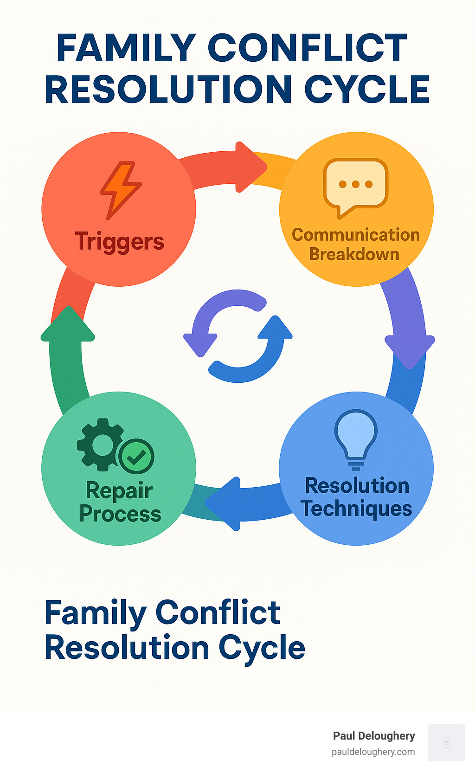
4
❌ Effects:
- Problem misunderstood
- Wrong advice given
- Person feels judged
- Heart issue ignored
- Situation becomes worse
🎭 Example:
Person: “My wife doesn’t respect me”
❌ Wrong perception:
👉 “Your wife is the problem”
🚫 Result:
- Blame increases
- Conflict grows

✅ 2. What Happens When Perception is RIGHT?
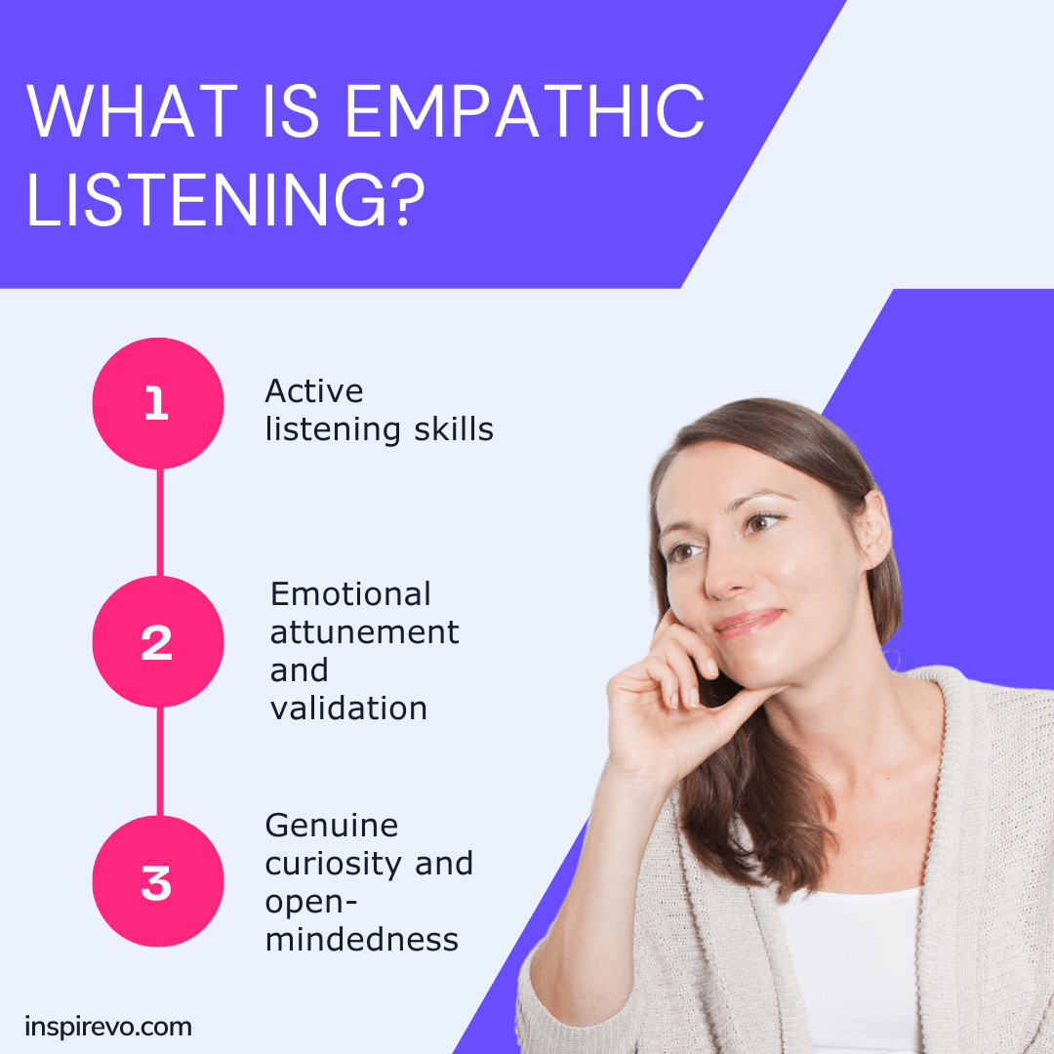


4
🌿 Effects:
- Heart is understood
- Right questions are asked
- Christ is introduced
- Healing begins
- Relationship is restored
🎭 Example:
Same situation
✅ Right perception:
👉 “What is happening in your heart?”
👉 “Do you feel hurt or rejected?”
✨ Result:
- Real issue identified
- Healing starts

✝️ 3. Biblical Insight
📖 Proverbs 18:13
👉 “To answer before listening — that is folly”
📖 1 Samuel 16:7
👉 God looks at the heart
💡 Teaching:
👉 Wrong perception = outward focus
👉 Right perception = heart focus

🌱 4. Counseling Model Connection
🌿 Model:
👉 Christ → Heart → Behavior → Relationship
Key Role of Perception:
- Detect heart condition
- Not just behavior

🪴 5. Simple Illustration (Very Powerful for Teaching)
👉 Imagine a tree 🌳
- Bad fruit 🍎 → Behavior problem
- Root problem 🌱 → Heart issue
❌ If you fix fruit → problem returns
✅ If you fix root → tree changes
💡 Conclusion:
👉 Right perception identifies the root

🧠 6. Teaching Formula (Easy to Remember)
👉 See → Understand → Discern → Guide
- See beyond words
- Understand emotions
- Discern heart
- Guide with Christ

💡 Powerful Teaching Lines
👉 “Misdiagnosis leads to mistreatment.”
👉 “Right perception is the doorway to transformation.”
👉 “You cannot heal what you do not understand.”

📌 Bilingual Teaching Version
English:
If a counselor sees only behavior, counseling fails.
But when the heart is understood, transformation begins through Christ.
Tamil:
ஆலோசகர் நடத்தையை மட்டும் பார்த்தால் ஆலோசனை தோல்வியடையும்.
இதயத்தை புரிந்துகொண்டால் கிறிஸ்துவின் மூலம் மாற்றம் ஆரம்பமாகும்

